The Structure and Function of the Respiratory System
GCSE PE – Revision Bo klet
Ap lied Anatomy and Physiology
Physical Factors Affecting Performance
Student Book





Respiratory System

What the Specification Says:

Learners must understand the pathway of air through the respiratory system. Learners must know the role of respiratory muscles used in breathing.
Learners must know the definitions of:
- breathing rate;
- tidal volume;
- minute ventilation.
Learners must understand about alveoli and gaseous exchange.

Definitions:

breathing rate –

– the volume of air that is inhaled per breath.

minute ventilation –

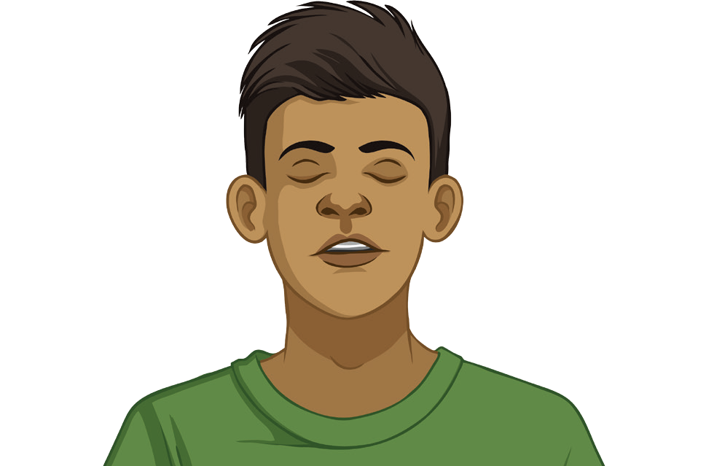

The Pathway of Air
Air travels through the respiratory system in the following way:
trachea
bronchi
bronchiole
alveoli
mouth/nose

Can you label the diagram?

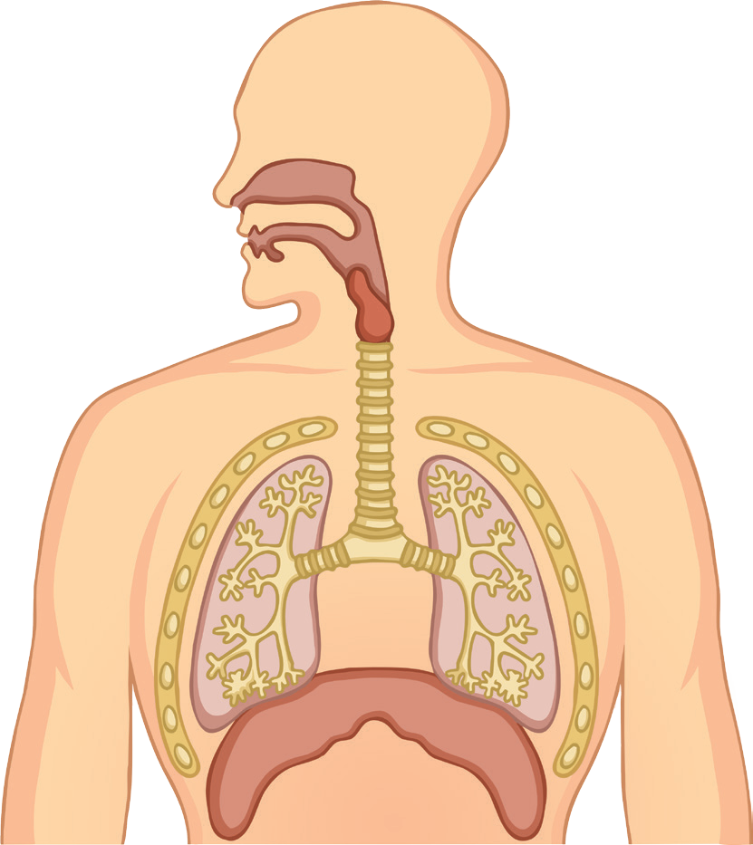

The Role of Respiratory Muscles in Breathing
The key muscles involved in breathing in (inspiration) and breathing out (expiration) are:

When you breathe in (inhale):
The respiratory muscles . The intercostal muscles move the ribs
and . The diaphragm contract and moves .
When you breathe out (exhale):

The respiratory muscles . The intercostal muscles move the ribs . The diaphragm relaxes and moves .

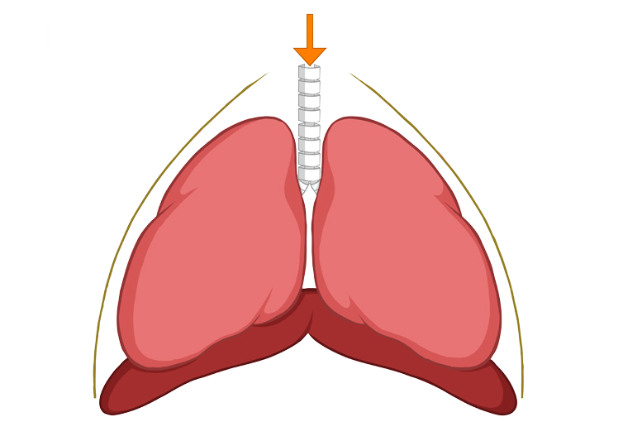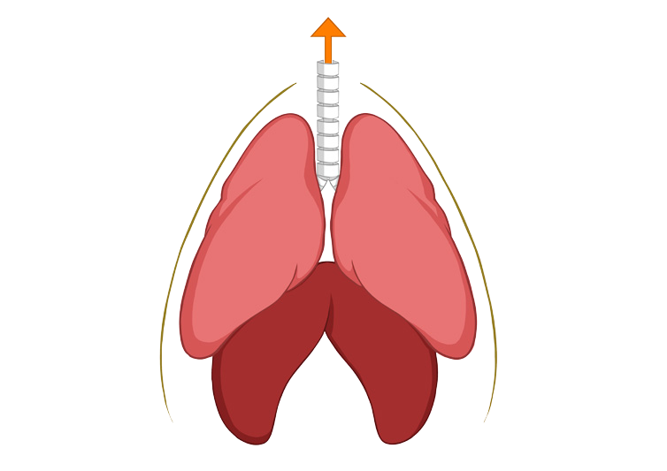

Extension Task: Draw a simple diagram of the respiratory system and add arrows to show the movements made by the different muscles involved in inhalation and exhalation.

Alveoli and Gaseous Exchange
Alveoli are responsible for .

Blood arriving at the alveoli has high levels of and lower levels of .
Blood leaving the alveoli has high levels of .

What type of athlete would benefit from having a greater ability to diffuse oxygen?

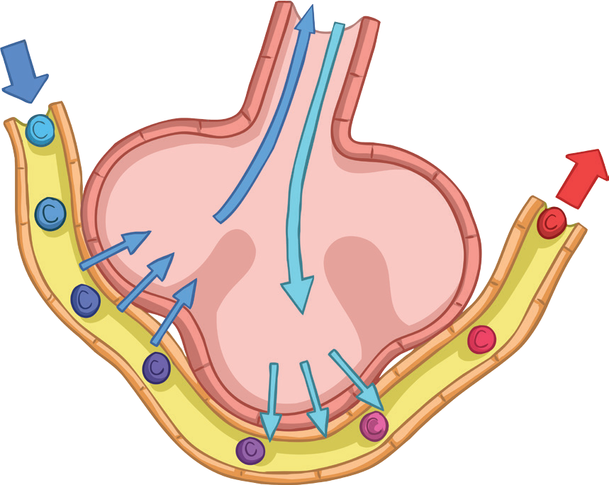 .
O₂ in
CO₂ out
oxygenated blood out
deoxygenated blood in
air in
air out

red blood cells in capillary
deoxygenated blood (blood cells blue for purposes of diagram only)

